**Online Courses System**

**Database Design**

The Online Courses System is designed to manage and streamline the various aspects of an online learning platform, including users, courses, messages, lessons, modules, grades, and content. Below are the requirements and relationships for the system.

**Requirements:**

**Users:**

* Each user has a user_id, a username, an email, a password, a role (student or instructor), and a created_date.

**Courses:**

* Each course has a course_id, a title, a description, a created_date, a pay_amount, and hours.

**Messages:**

* Each message has a message_id, a subject, a content, and a time.

**Content:**

* Each content has a content_id, a title, a content_type, and a file_path.

**Lessons:**

* Each lesson has a lesson_id, a title, and content.

**Modules:**

* Each module has a module_id, a title, and a description.

**Grades:**

* Each grade has a grade_id and a grade.

**Relationships:**

**1- User-Course Relationships:**

* A student can enroll in multiple courses (M relationship).
* An instructor can provide multiple courses (1 relationship).

**2- Course-Module Relationships:**

* A course contains multiple modules (1 relationship).

**3- Module-Lesson Relationships:**

* A module contains multiple lessons (1 relationship).

**4- Lesson-Content Relationships:**

* A lesson has multiple contents (M relationship).

**5- User-Message Relationships:**

* Users (students and instructors) can send and receive multiple messages (M relationship).

**6- Course-Grade Relationships:**

* A course provides multiple grades (1 relationship).

The detailed entity-relationship diagram (ERD) visually represents these entities and their relationships.

By defining these requirements and relationships, the Online Courses System ensures efficient management of course materials, user interactions, and academic performance.

* **ERD**

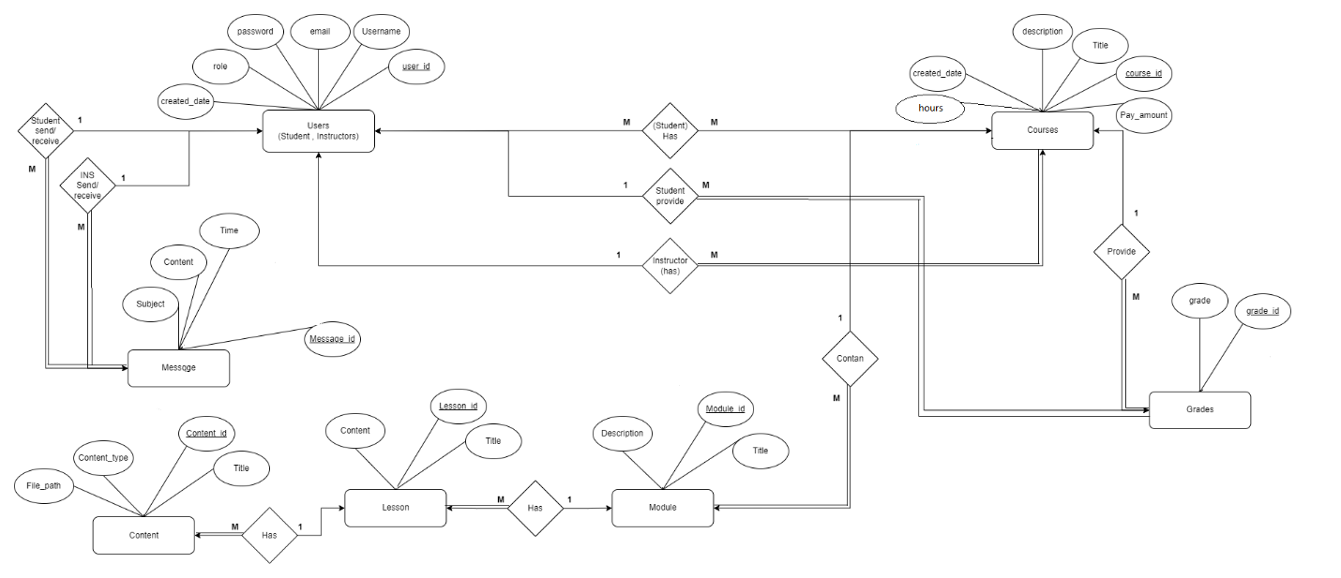

* **Mapping:**

* **Topics**
* **Views**
* View StudentsOnly() (to show All students only)
* View InstructorsOnly() (to show All Instructors only)
* View EnrolledCoursesOnly () (to show Enrolled Courses only)
* View NonEnrolledCoursesOnly() (to show Non- Enrolled Courses only)
* View InstructorsWithoutCourses() (to show Instructors Without Courses)
* View StudentsNotEnrolledInCourses() (to show Students Not Enrolled In any Courses)
* **stored procedure (Insert process)**
* Insert User ( insert data to User table)
* InsertCourse (insert data to Course table)
* InsertModule (insert data to Module table)
* InsertLesson (insert data to Lesson table)
* InsertContent (insert data to Content table)
* InsertEnrollment (insert data to Enrollment table)
* InsertGrade (insert data to Grade table)
* InsertMessage (insert data to Message table)
* **stored procedure (Update process)**
* UpdateUser ( update data in User table)
* UpdateCourse ( update data in Course table)
* UpdateModule ( update data in Module table)
* UpdateLesson ( update data in Lesson table)
* UpdateContent ( update data in Content table)
* UpdateEnrollment ( update data in Enrollment table)
* UpdateGrade ( update data in Grade table)
* **stored procedure (Delete process)**
* DeleteUser (delete data from User table)
* DeleteCourse (delete data from Course table)
* DeleteModule (delete data from Module table)
* DeleteLesson (delete data from Lesson table)
* DeleteContent (delete data from Content table)
* DeleteEnrollment (delete data from Enrollment table)
* DeleteGrade (delete data from Grade table)
* DeleteMessage (delete data from Message table)
* **Function:**
* GetTopNCoursesWithHighestSold ( to get Top N Courses With Highest Sold)
* FUNCTION show_course_with_grade (show a specific course with it's grade)
* FUNCTION show_student_courses_and_grades (show his all courses and his grades)
* **Trigger:**
* Stop_deleting (stop all the delete process from enrollment table)
* Log_data (Store all the log information for the insertion on enrollment table)
* FUNCTION show_instructor_courses_and_enrollment_count (show all his courses and the count of student enrolled in)
* FUNCTION show_instructor_courses_with_highest_enrollment (show all his courses with the highest enrolled)
* FUNCTION show_instructor_courses_with_no_enrollments (show all his courses with no enrollments)
* FUNCTION search_instructors_by_name (show all the instrucors name with he searches for)
* FUNCTION show_instructor_courses_and_student_count (show all the courses to a spesific instructor)
* FUNCTION search_courses_by_name (Show all courses name with he searches for)
* get_course_details (show The Course data , course's modules , course's lessons and course's contents to a specific course)
* **Index: (**Indexes are used to make the search process Faster):
* IDX_User_Username (index on username in the User table)
* IDX_Course_Title (index on Title in the Course table)
* **Cursor**
* **GetUserAndGradesInCourse** (return all the student names and grades that enrolled in this course)
* **Rule**
* **Create Rule Grade_Values AS @values IN(‘A’ , ’B’ , ’C’ , ’D’ , ’F’)** (putting a Rule to the Grade to make sure that what we will insert will be a real grade).
* **Constraints**
* **Alter Table [User] ADD CONSTRAINT check_role CHECK (role IN (‘student’ , ‘instructor’)** (Putting a constraint to make sure that we will have just a student or instructor in the User table )
* **Business questions and answers:**

**Q1) how can we display students who are not enrolled in any courses in the online course system?**

A) we created a view called "StudentsNotEnrolledCourses" that displays username and email when rule is "Student for students who are not enrolled in any courses.

**Q2) how can the system display instructors who do not have any courses assigned to them?**

A) we created a view called "InstructorsWithoutCourses" that displays username and email when rule is " instructor" instructors without any assigned courses.

**Q3) how can the system display all instructors within the online course system?**

A) we created a view called "InstructorsOnly" that displays username and email when rule is " instructor" for all instructors registered in the online course system.

**Q4) how can the system display all students enrolled in the online course system?**

A) we created a view called"StudentsOnly" that displays username and email rule when rule is " Students" for all students enrolled in the online course system.

**Q5) how can the system show courses with the highest n of courses ordered by the count of students enrolled in?**

A) we created a function called " GetTopNCoursesWithHighestSold " that take @TopN as a parameter and return TOP (@TopN) course_id, title, COUNT (c ourse_id) To fetches the top N courses with the highest number of students enrolled.

**Q6) how can the system display courses where no students are currently enrolled?**

A) we created a view called " NonEnrolledCoursesOnly " that desplay course_id, title,and description for courses it fetches all courses where no students are currently registered.

**Q7) how the student will show a specific course with it's grade?**

A) We created function called ‘show_course_with_grade’ that will take the student_id nd course_id and will return to you a table contains the course data.

**Q8) how the student will show his all courses and his grades?**

A) we created a function called ‘show_student_courses_and_grades’ that will take a student_id and returns a table contain all the courses and grades data.

**Q9) how the instructor will show all his courses and the count of student enrolled in ?**

A) we created a function called 'show_instructor_courses_and_enrollment_count’ that will take an instructor_id and return the table contain the data.

**Q10) how the instructor will show all his courses with the highest enrolled?**

A) we created a function called ‘show_instructor_courses_with_highest_enrollment’ that will take an instructor_id and will return a table contain the data

**Q11) how the instructor will show all his courses with no enrollments?**

A) we created a function called ‘show_instructor_courses_with_no_enrollments’ that will take an instructor_id and return a table contail the data

**Q12) how the search bar will show all the instrucors name with he searches for?**

A) we created a frunction called ‘search_instructors_by_name’ that will take the string that user search with and give it to this fuction to return a table caontain with all the names like his sting to make his search easer.

**Q13) how the instructor will show all the courses to a spesific instructor?**

A) we created a function called ‘show_instructor_courses_and_student_count’ that will take an instructor_id and retuen a table contain the data.

**Q14) how the system will show all courses name with he searches for?**

A) we created a function called ‘search_courses_by_name’ that will take a search_term and this is a string which user searches with, and then give you a table contain all the similar courses name like the search string.

**Q15) how the system will show The Course data , course's modules , course's lessons and course's contents to a specific course?**

A) we created a Function called ‘get_course_details’ that will take the course_id and return a table contain all the courses , modules, lessons and contain data to this course.